Trying SSRF on LOCAL SERVER
GOAL: My Goal was to change the stock check url to acess the admin interface and delete a user named Carlos I documented my process as follows
Step 1:
After connecting my foxy proxy to my burpsute this is what I got after clicking on a link, I clicked on a linked named “view details” on the test website and got the results below ;
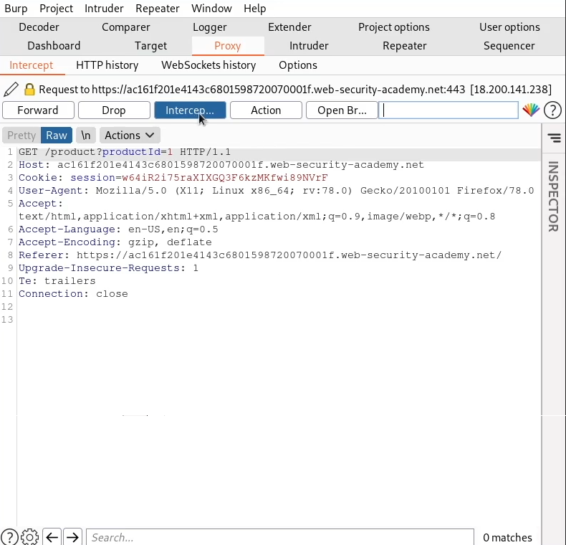

Step 2: i clicked on check stock button and it gave me this results as show below, I clicked on Line 13: and right clicked and sent to Repeater
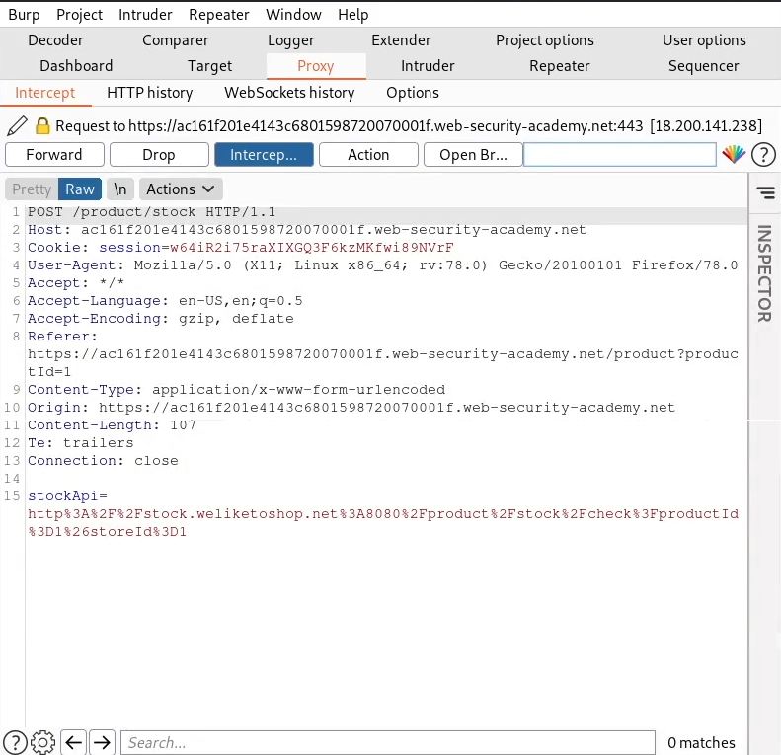

Step 3: after opening the repeater tab which is shown below;
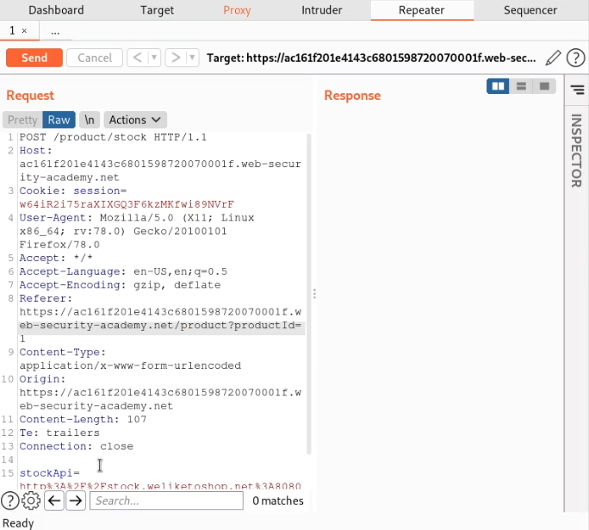
I highlighted the link for StockApi and hit Ctrl + Shift + U on my keyboard to decode it after decoding I sent a request as shown below
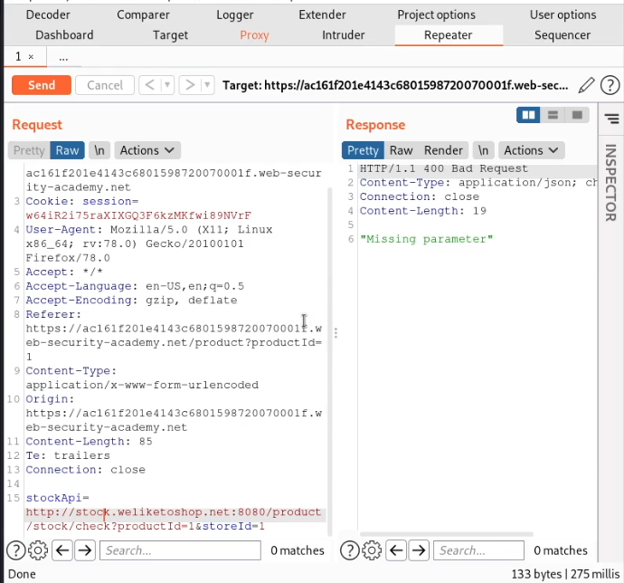
It showed missing parameter as shown above with a 400 Bad request as my response so I encoded it back using Ctrl + U and I sent a request which gave me this result as shown below with a 200 OK as my response and gave the number of available items of stock which is 388 and is also shown below

